Cable-Shift
Instructions
Subaru

- Fabricate the mount for the Cable-Shift box. The shifter box is normally secured by the pre-punched 1/4” diameter holes at the base of the sides. Two through tubes 2-7/8” long are used on the chassis with a single center tube. On a chassis with two center tubes, 1/8” brackets are drilled to match the holes in the shifter box, then welded to the center tubes.

- Next the gate cable bracket and shift rod coupler are removed from the cables at the transaxle end. The gate cable bracket is secured to the gear carrier end plate by three 12mm bolts at the top of the gear carrier section, and two 8mm bolts, on the left side of the gear carrier housing as viewed from the rear. The coupler assembly is located on the transaxle shift rod by a 5/16” set screw tightened into the shift rod through hole previously used by the stock linkage roll pin. Note: Stock transaxle shift linkage arm and set screw must be removed.
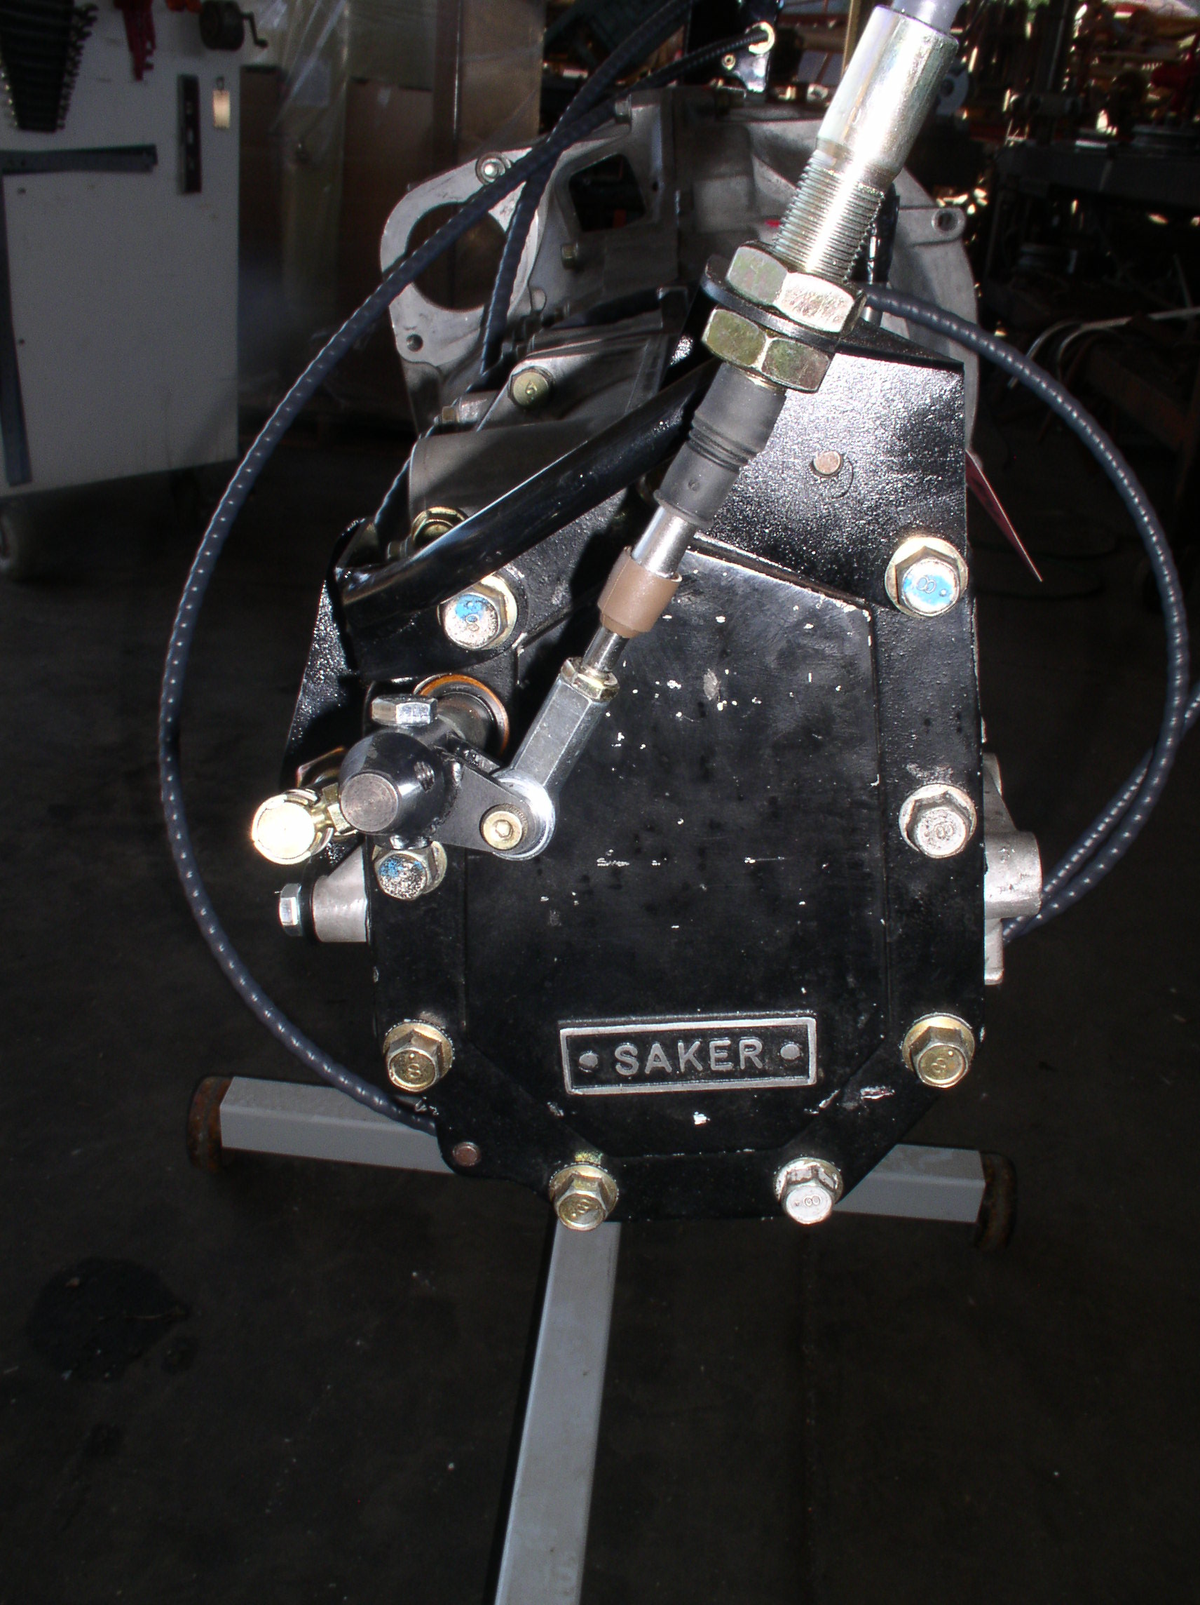

- The shift cables may now be installed. The main (longer) cable will approach the shift rod coupler approximately parallel to the transaxle centerline; the gate (shorter) cable is positioned 90 degrees to tranny center line vertically to meet the main cable, the cables then run parallel along the route defined during cable measurements. The gate (shorter) cable is passed through the 5/8” hole in the gate cable bracket and is secured by jam nuts on either side of the bracket. The ¼” rod end at the end of the cable is then secured between the arms of the shift rod coupler with a ¼” fastener.

- The main cable is secured on either side of the bracket by a 5/8” jam nut. The end of the main cable is attached to the coupler ball stop by a Quick Disconnect socket. When all fasteners are secured adjustment of the shifter can begin. Initial adjustment to ‘run through the gears’ can be made in the shop before the engine is running. Final adjustments and ‘fine tuning’ should be made under driving conditions.

Cable-Shift
Adjustments
Subaru

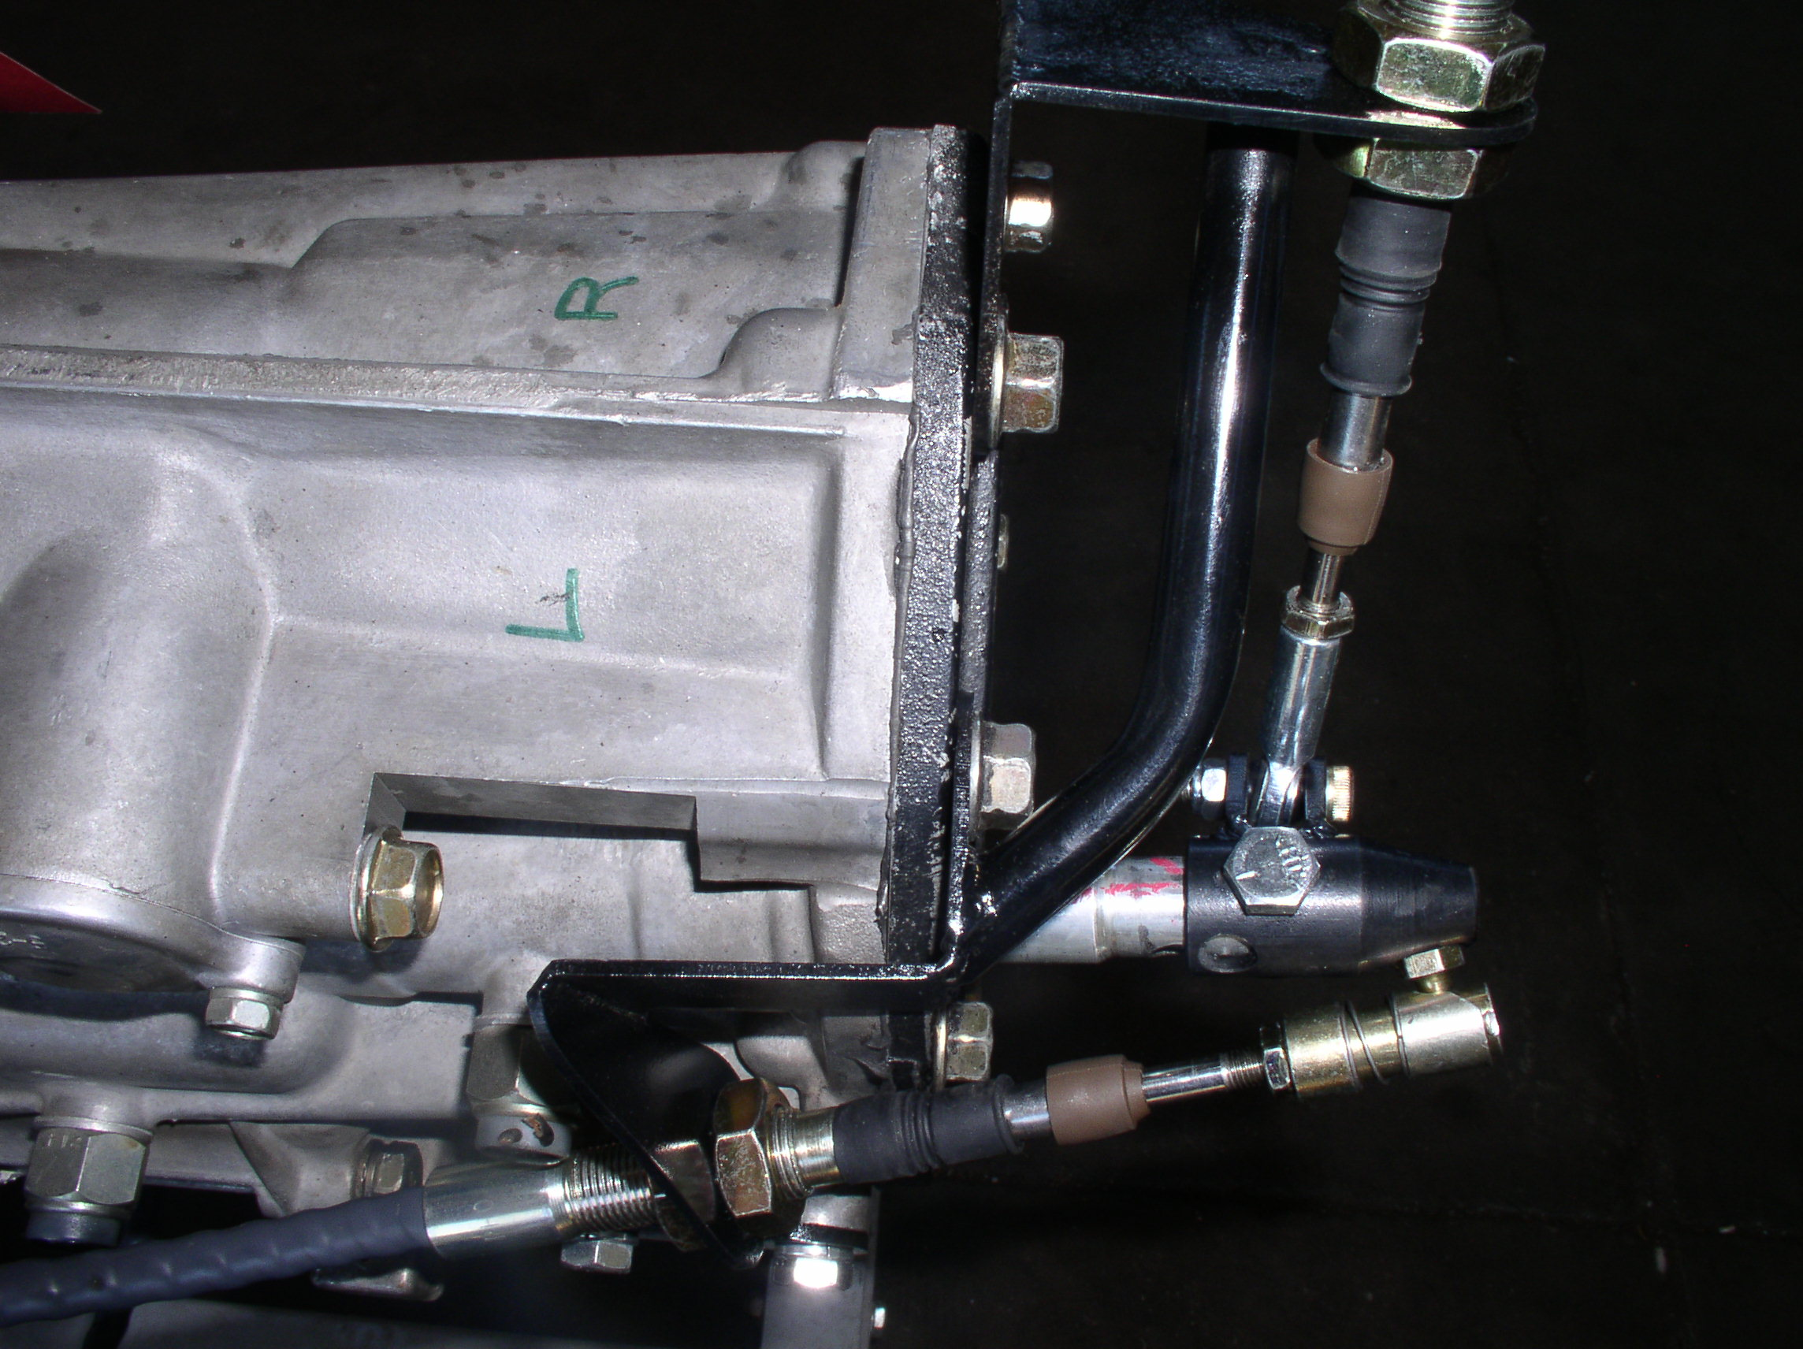
- Set the depth of shift. First disconnect the ¼-28 Quick Disconnect from the shift rod coupler ball stud and pull the shift rod coupler into second gear (1-2 gate, rearward position). Pull the shift handle rearward into the second gear position as well, now with a minimum of 3/16” of cable end threaded into the ¼”-28 QD, adjust the 5/8” jam nuts on the main cable, so the ¼” QD fits over the shift rod coupler ball stud. Then, remove the ¼” QD, push the shift rod coupler forward (into first gear) and repeat adjustment until the shift handle functions through the middle of its travel.

- Set the gate position. There are 3 gates in a 5-speed Subaru transaxle (4 gates in a 6-speed conversion). A gate and depth of shift diagram for a Subaru 5-speed transaxle is shown below:

Gate
1 3 5

2 4 R
Depth
Of
Shift

Pull the shift rod coupler into fourth gear, loosen the ¼” jam nut on the gate cable and remove the ¼” bolt from the coupler arms. Gently slap the shift handle against the Cable-Shift reverse lock out bar. Adjust the gate cable rod end to fit onto the ¼” bolt between the coupler arms and “finger tighten” the 5/8” jam nuts. The Cable-Shift shifter should be close enough to ‘run through the gears’. Shifting will improve when the engine is running and the clutch is depressed. Shifting further improves as synchronizers are worn in.

- Fine adjustment of the gate cable. Fine adjustment of the gate cable is usually necessary after initial test drive, to make a smoother down shift from fifth to fourth and third to second. A diagram is provided to show this adjustment: 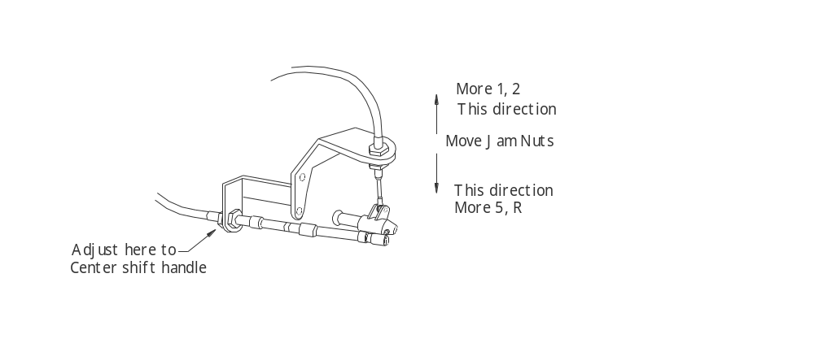

Small adjustments (1/6 turn) made at the gate cable quick disconnect makes a noticeable difference. A smooth shift sequence is therefore attainable, first through fifth gears and reverse.

- When the Cable-Shift shifter has been adjusted to the drivers ‘driving style’ under driving conditions, tighten all jam nuts, re-tighten bracket fasteners and recheck shifting sequence.

